# Recipes

You need to add 17 things to this document. (Make sure to number them just as I did in the example.) It may be helpful to copy and paste this list and then fill it in as you go along. All image names must start with your location, e.g yellowstone_sunset.jpg unless you are using a link from the internet.

## Chinese Hot and Sour Soup

1. **Origin**: China
2. **Source**: tofu, mushrooms, and bamboo shoots
3. **Category**: Soup
4. 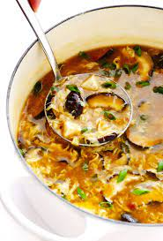
5. ChineseHotandSourSoup1.jpeg
6. Chinese Hot and Sour Soup (酸辣汤) is a popular and flavorful soup known for its spicy and tangy taste. It's made with a variety of ingredients including tofu, mushrooms, and bamboo shoots.
7. **Recipe Ingredients – Just write Recipe Ingredients**
   1. Tofu
   2. mushrooms
   3. water
   4. pork
   5. bamboo shoots
   6. soy sauce
8. **Recipe Steps – Just write Recipe Steps**
   1. Boil
   2. Simmer
   3. Cooking
   4. dipping sauces
9. **Additional Food images**

For the next three pictures you can just put the names of the files, you don't have to include the files in this drive, but you do need to add them to the proper Google Drive.

1. ChineseHotandSourSoup2.jpeg
2. 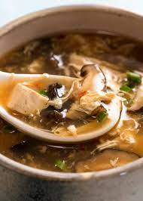
3. ChineseHotandSourSoup3.jpeg
4. 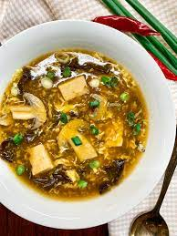
5. ChineseHotandSourSoup4.jpeg
6. 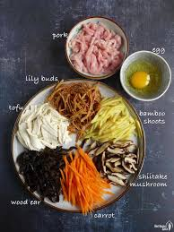
7. Guanhua Xue